Course (from Linkedin Learning):- Python For Data Science Essential Training Part – 1

Module – 3 Data Visualization 101

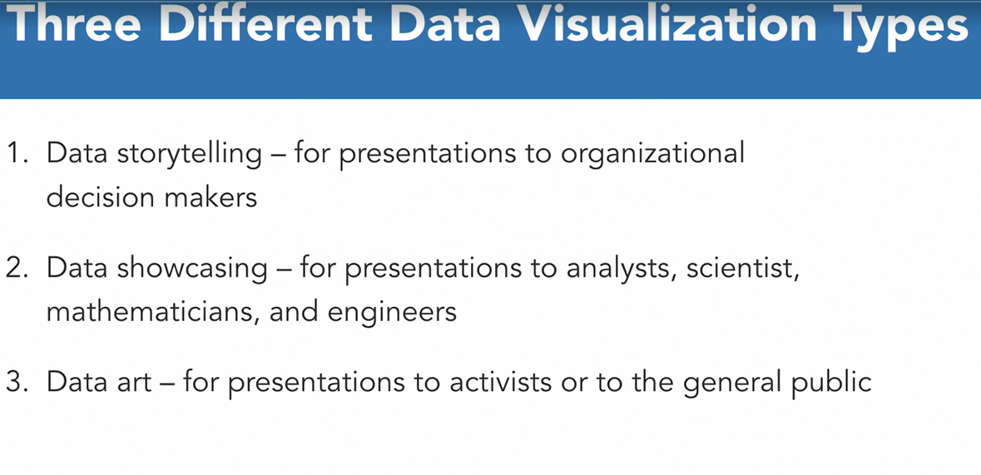

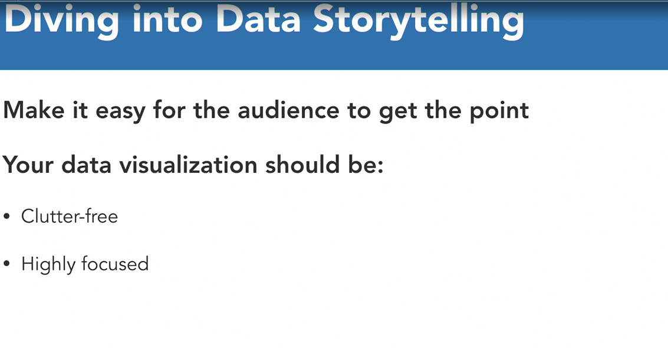

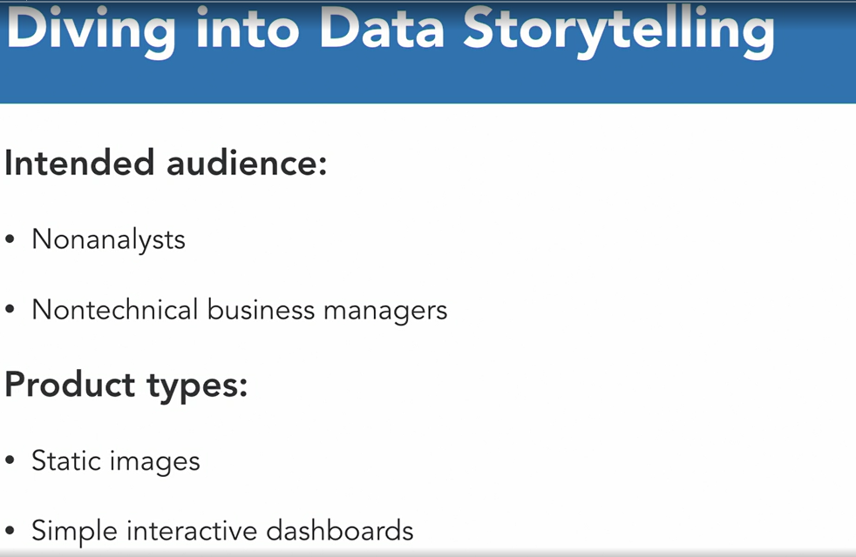

Example of Data StoryTelling

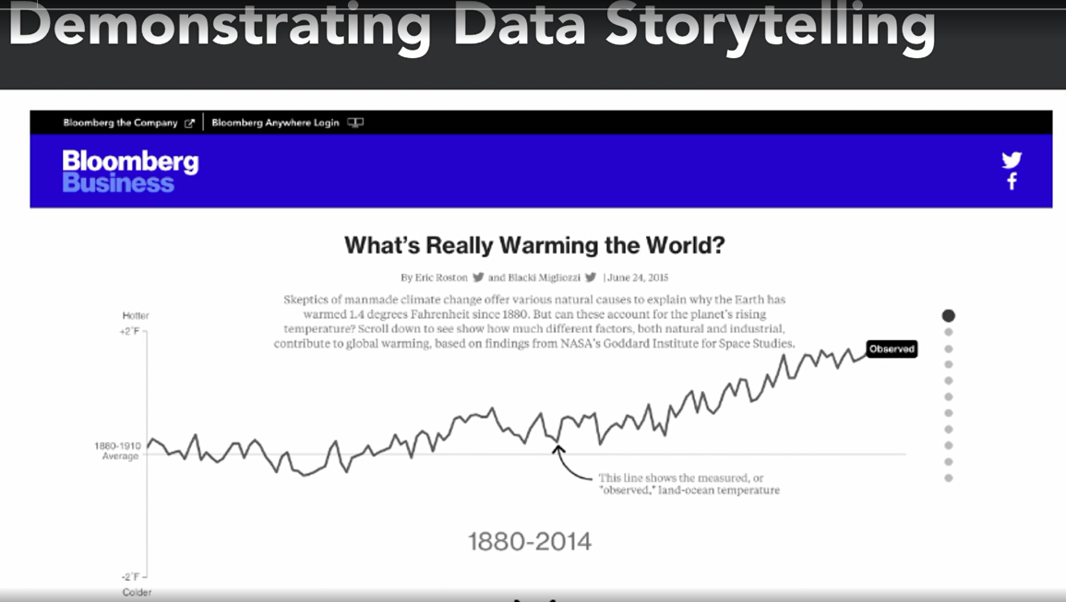

2) Data ShowCasing :-

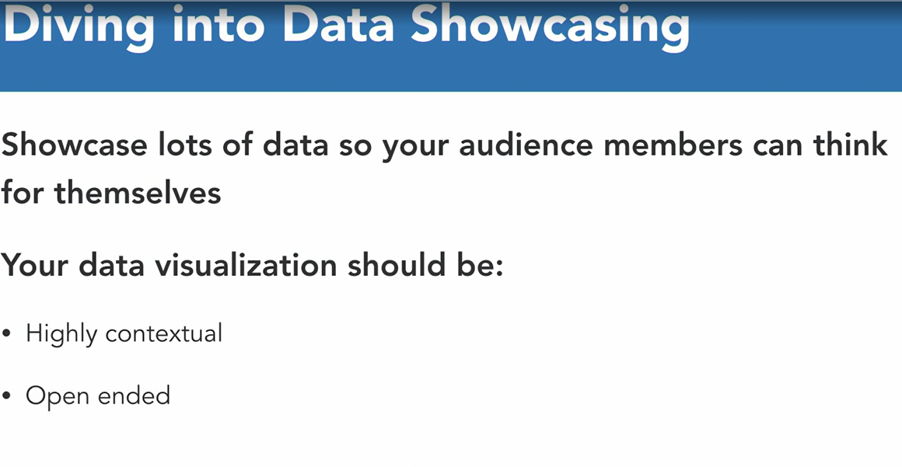

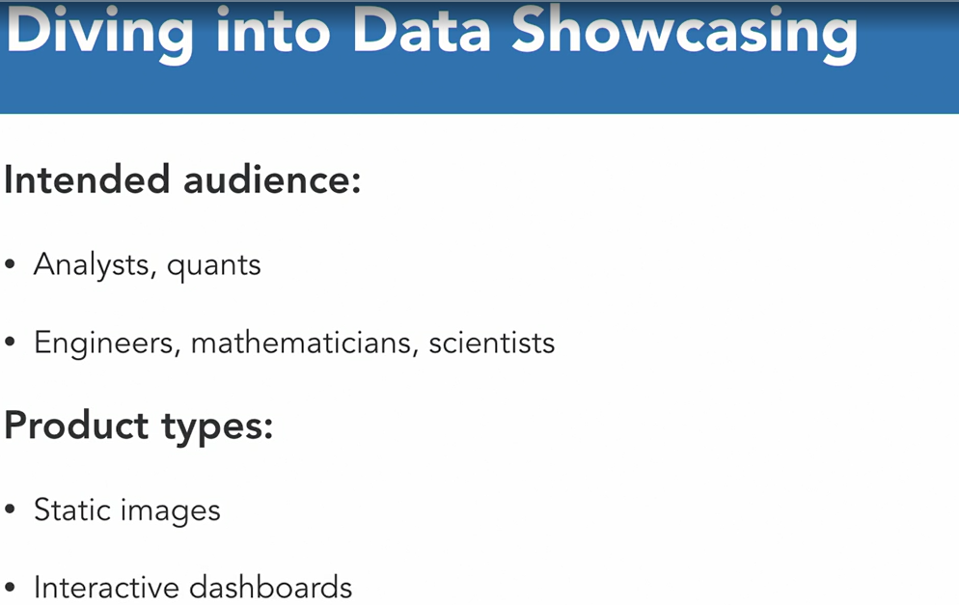

Example of Data Showcasing

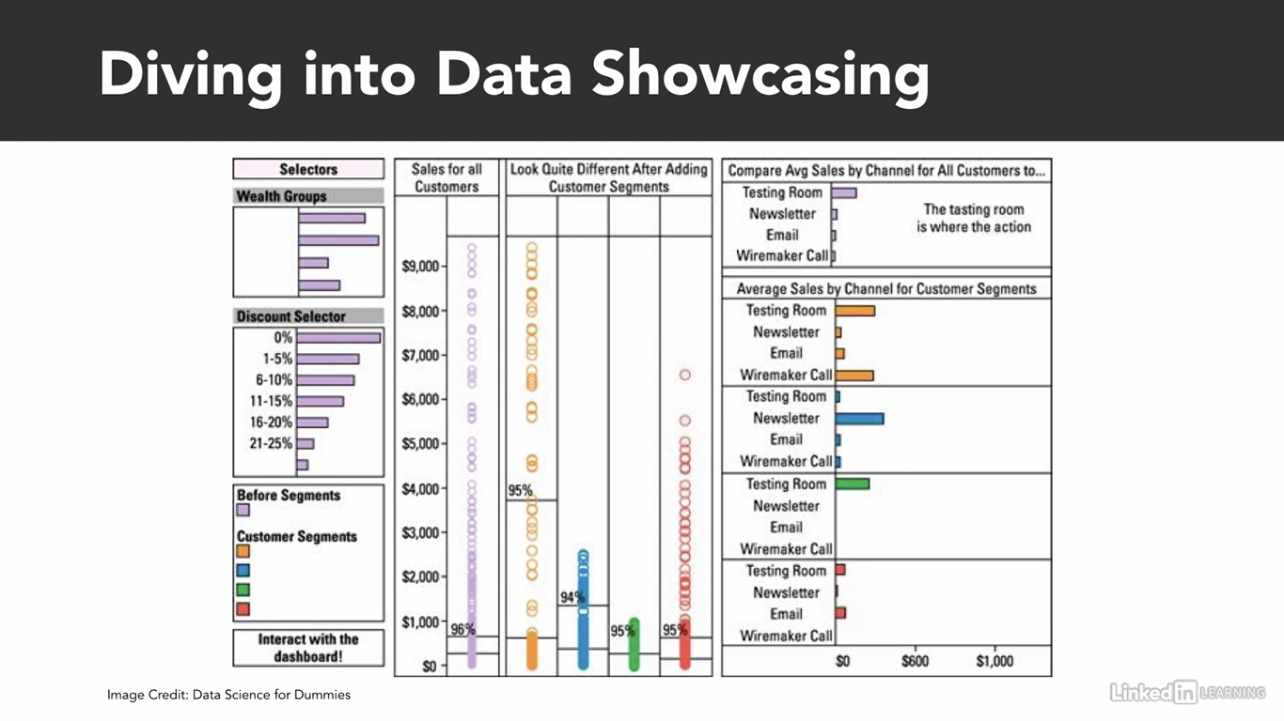

3) Data Art :-

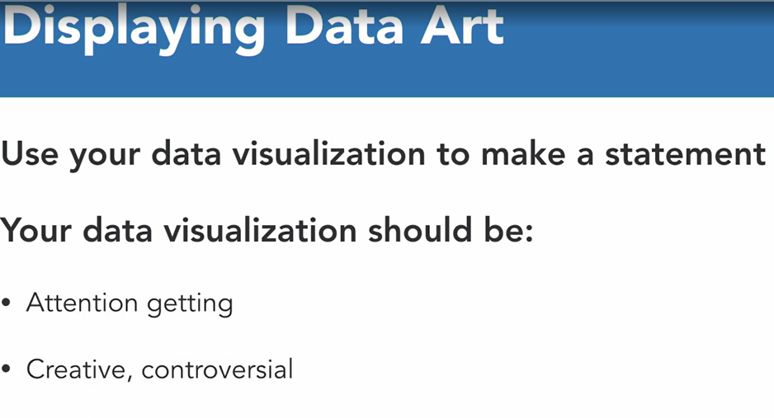

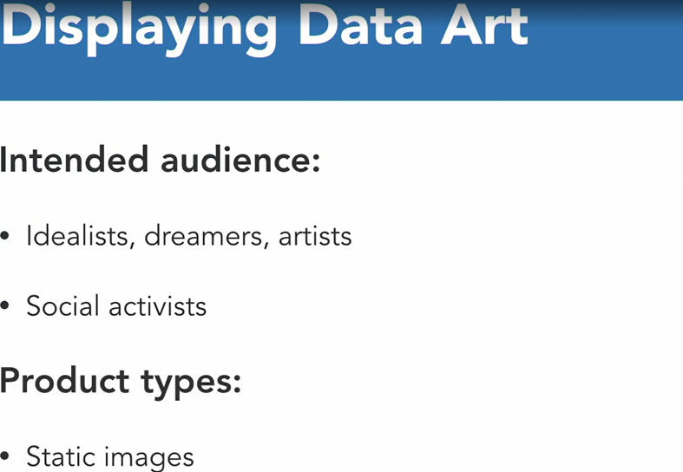

Example of Data Art :-

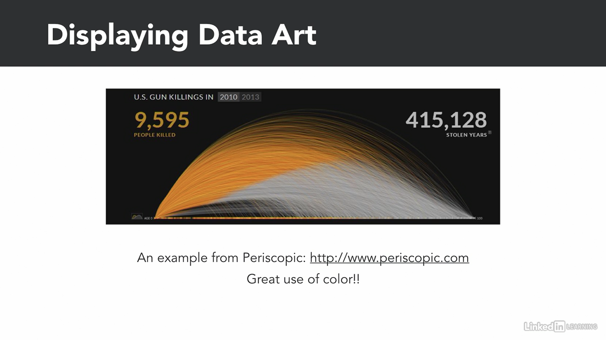

Now Select Optimal Data Graphic Tool :-

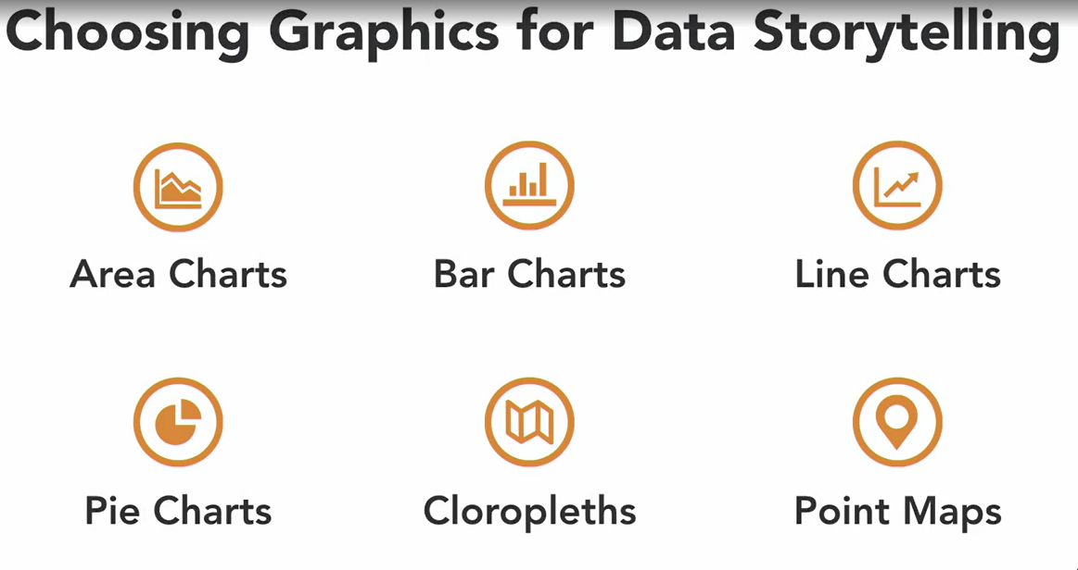

Example of Choropleths:-

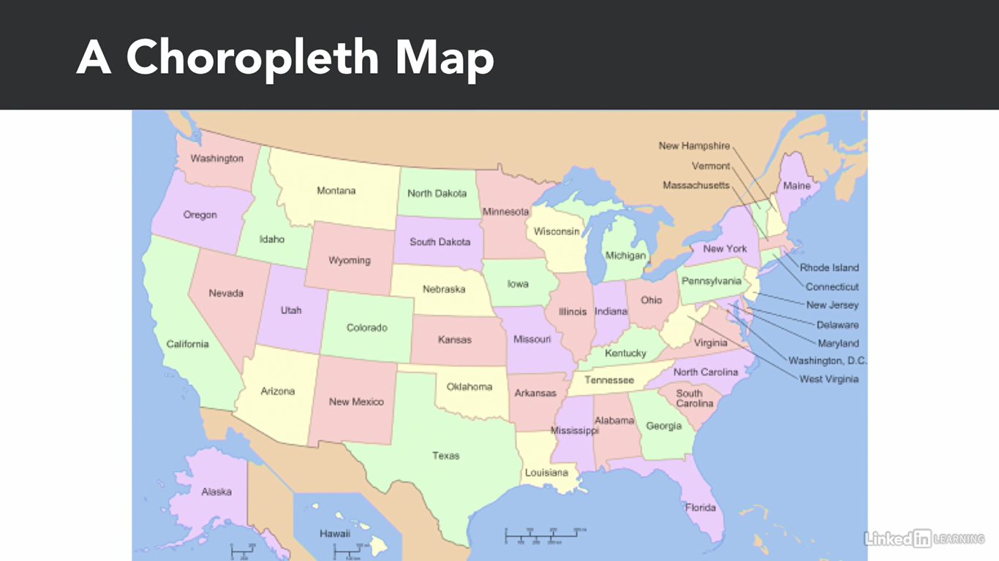

Example of Point Map :-

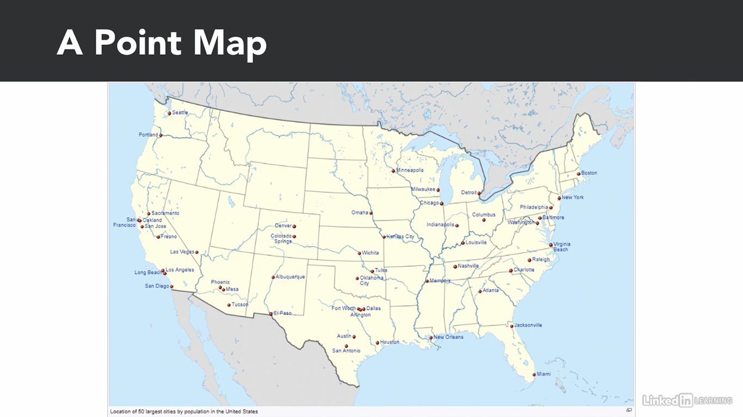

Choosing Graphics for Data Showcasing :-

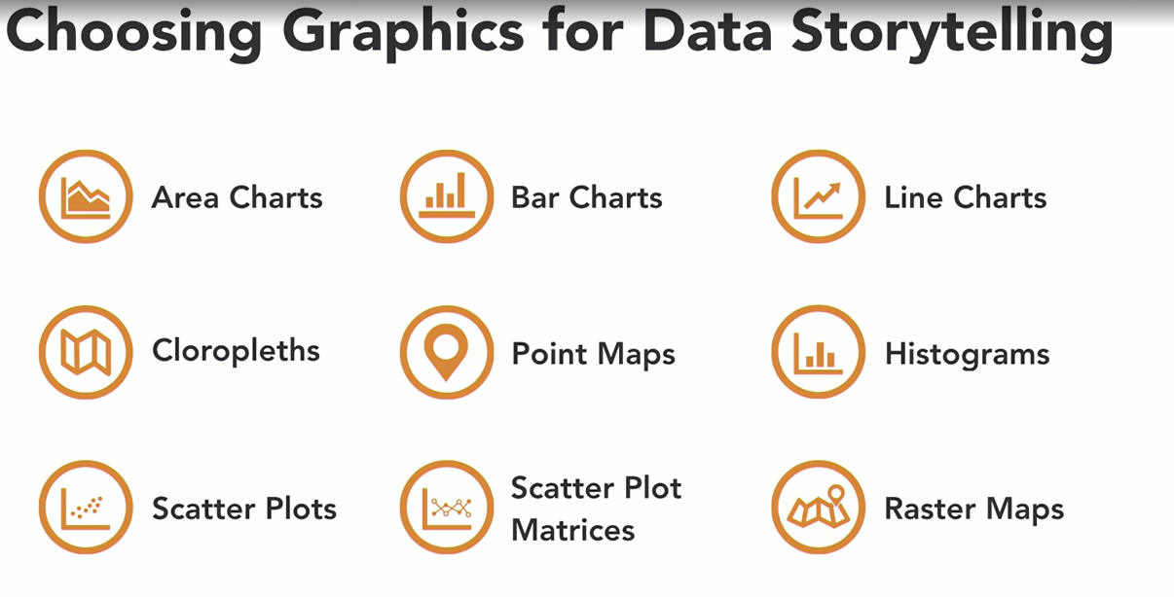

Example of Raster Maps :-

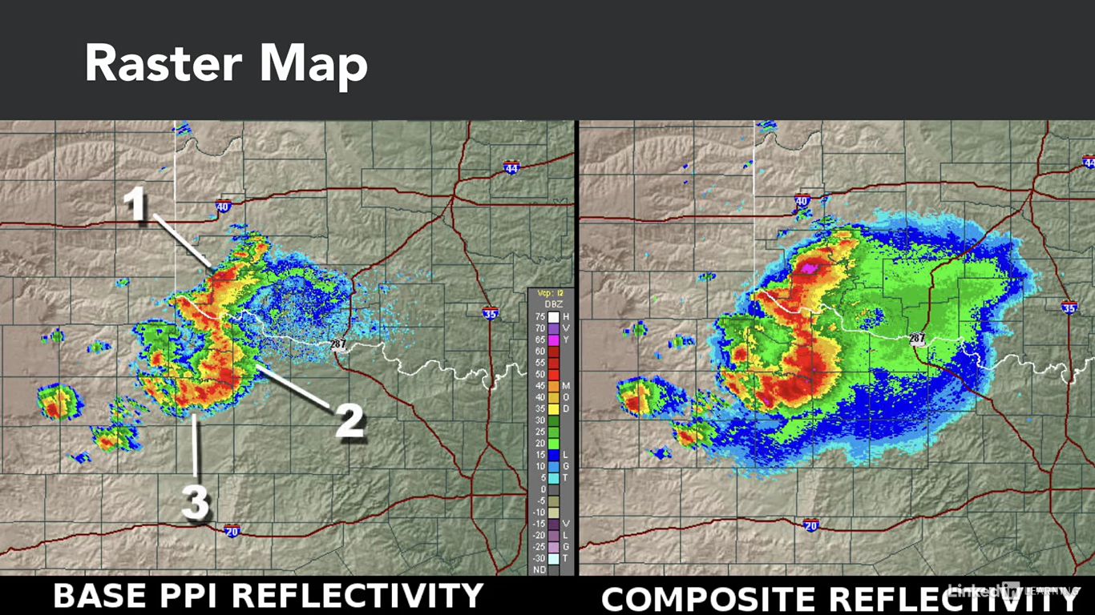

Choosing Graphics for Data Art :-

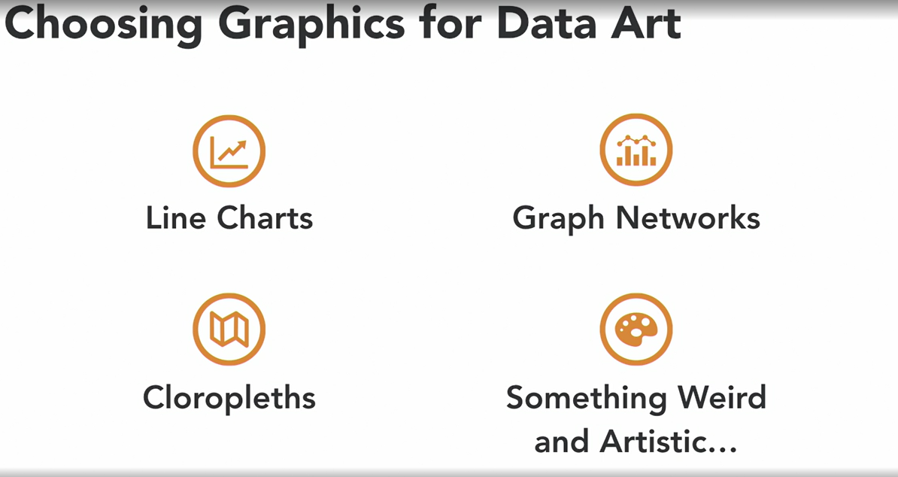

Example :-

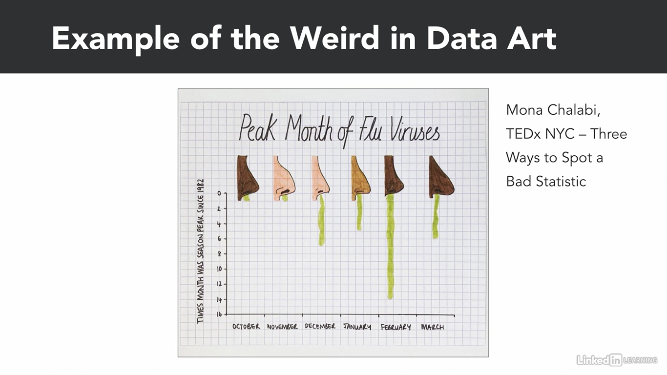

4 Steps to choose right graphic tool. Or how to decide right graphic tool for data visualization :-

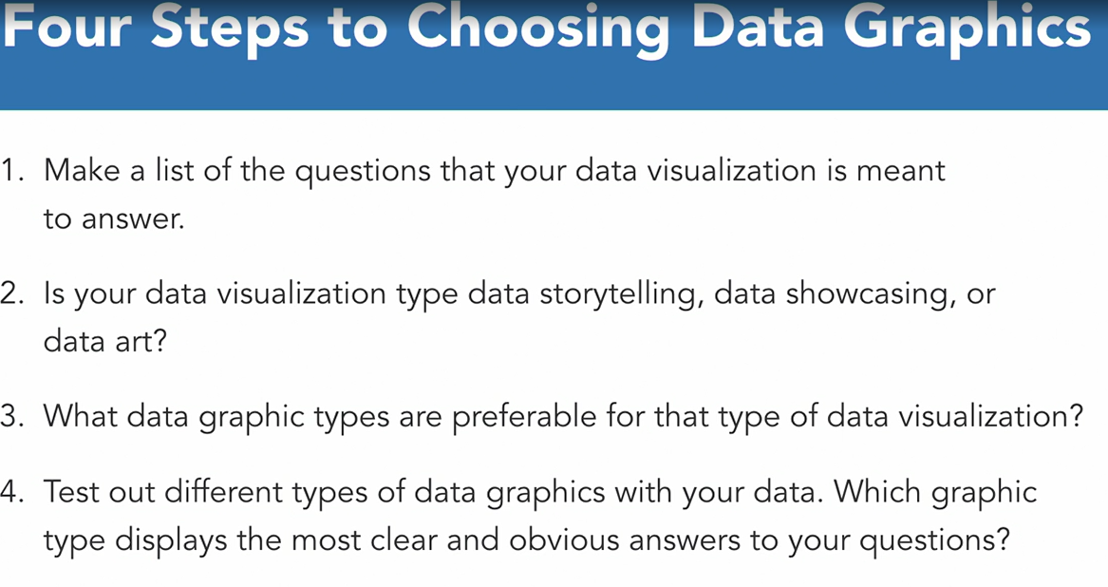

4th Step continues:-

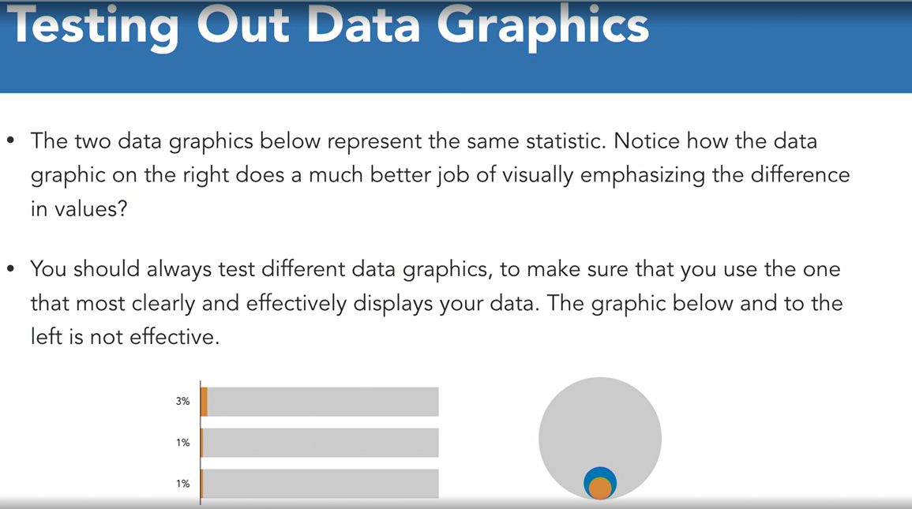

Lecture – 3 :- Communicatin with color and context

This is remaining. Pls add SS in your free time.

Module – 4 :- Practical data visualization :-

So char representation is most common and generic and useful way to represent or visualize data. So let’s learn how to visualize data in terms of charts first (line charts, bar charts, pie charts).

Pls include SS here.

So there are mainly 2 ways to visualize data.

Functional way :- it means we are applying functions and method on some variable or dataset or subset of data set to plot or visualization.

Object – Oriented Way :- In Object Oriented way, first empty object will be created and in that object afterwords variable or data elements and it’s corresponding graph elements will be added.

Pls include SS.

\*\***Functional way :-**

Let’s create standard data graphics using Matplotlib and Seaborne.

Creating line chart from a list object. :-

So first we need to have object for 2 axis in chart.

X = range(1,10) # will generate list of numbers from 1 to 9.

Y = [1,2,3,4,0,4,3,2,1]

Now to generate a line chart, what w need is plot function. And pass both this object into it as an argument for x and y axis.

Plt.plot(x,y)

Now creating a Line chart from a Pandas Object :-

Mpg_data = cars[‘mpg’]

Mpg_data.plot()

Now let’s generate a line chart which is plotting 3 variables on graph.

So for that first of all, we need to create dataframe.

Df_data = cars[[ ‘cyl’ , ‘wt’ , ‘mpg’ ]]

Df_data.plot()

**Creating Bar Charts :-**

Creating Bar chart from a list object:-

So to generate bar chart, we are having bar function.

Plt.bar(x,y)

Creating bar chart from a pandas bject :-

So to generate bar chart from pandas object, we need plot() function nly. Bt with specific argument to generate chart as bar chart.

Mpg_data.plot( kind=’bar’ )

Now u will be able to see bar chart and is layed out vertically on the screen. Bt now what if you want bar chart for same dataset bt in horizontal manner? We only need to append alphabet h after ‘bar’ while passing the argument.

Mpg_data.plot( kind=’barh’)

**Creating Pie Chart :-**

To create pie chart from list we need to have pie function.

X = [1,2,3,4,0.5]

Plt.pie(x) # this will only generate pie chart bt won’t show on the screen.

So to show on the screen in case of pie chart, we need to use show function.

Plt.show() # will show on the screen.

**Saving plot as an image :-**

so let’s see how to save pie chart. To save a pie plot we need to create pie plot and then apply savefig method to save it.

Plt.pie(x)

Plt.savefig( ‘pie_chart.png’ ) # this will save the plot named as argument name. and it will save it in your present working directory. (in jupyter if u want to check your present working directory, then run %pwd command).

**Lecture – 2 :- Defining Elements of a Plot.**

Now let’s learn how to define elements of a plot using matplotlib.

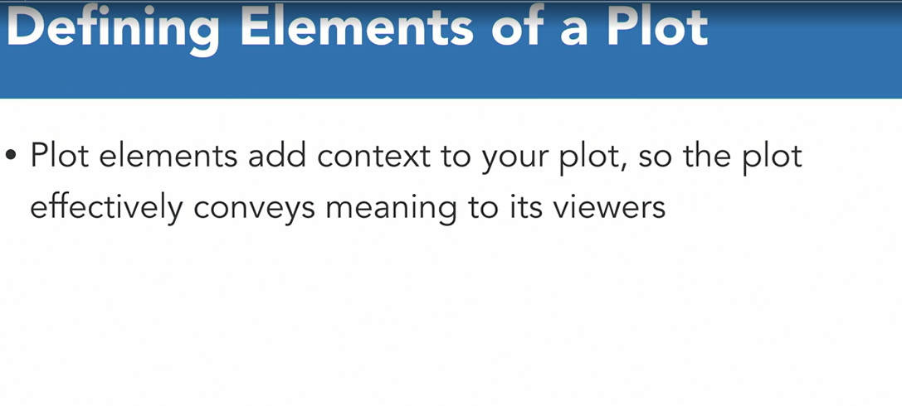

**There are 2 methods to plot.**

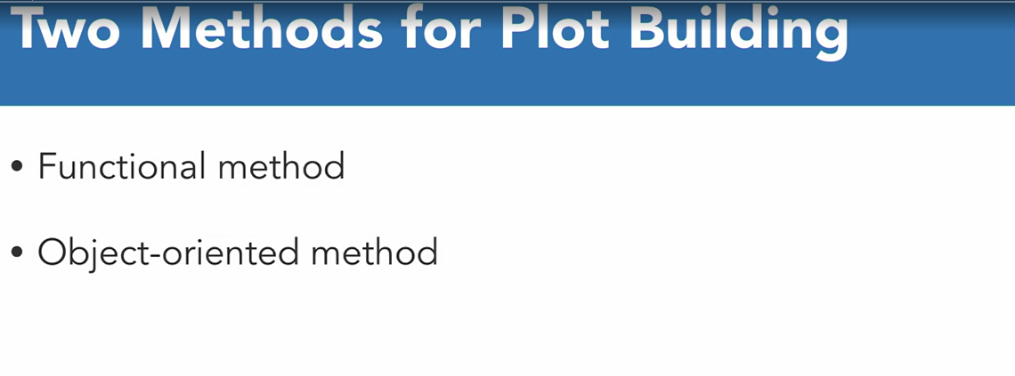

Matplotlib. So previously we have seent how to build plots in funcational way. Now let’s see object oriented way. So as we know in object oriented way, first we need to create blank figure object. And then need to fill it with plot and plot elements to build plot.

Below are the steps to generate the plot using object oriented method.

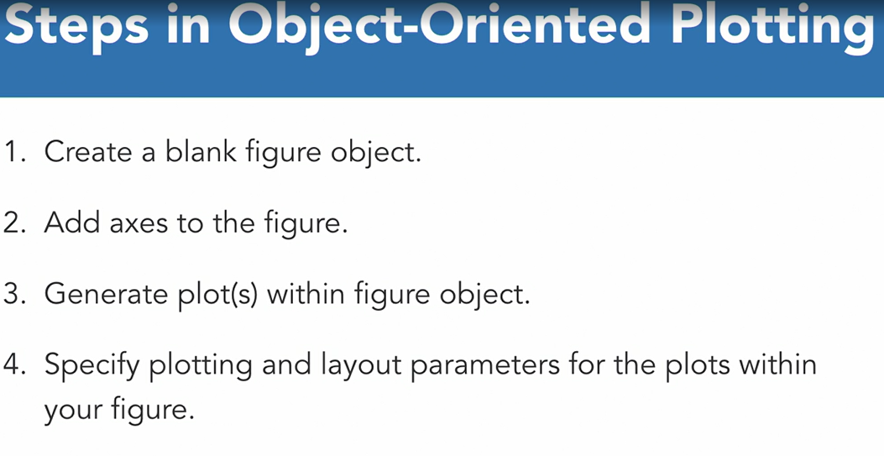

One more important thing in ploting is subplot. And it is very easy to plot subplot using subplots function in matplotlib.

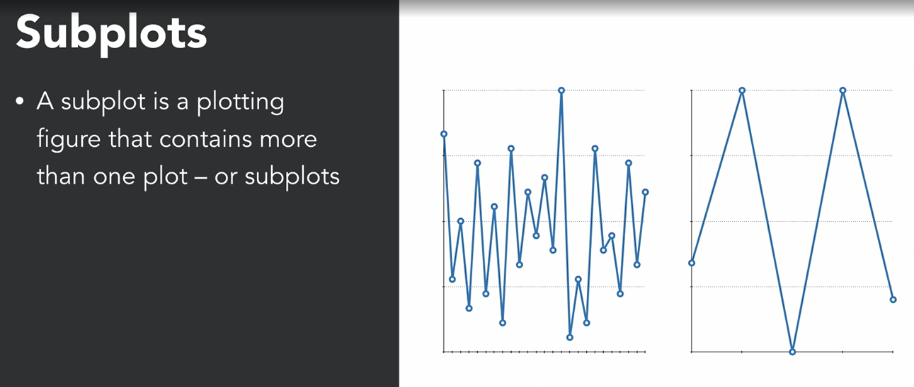

Now finally let’s learn practicall how to generate plot.

Import numpy as np

From numpy.random import randn

Import pandas as pd

From pandas import series,datafreame

Import matplotlib.pyplot as plt

From matplotlib import rcParams

So we have imported all the required libraries and modules and functions from that libraries.

Now first thing we need to do is to set plot in line and with proper figure in the jupyter notebook screen.

%matplotlib in line # this command tells python to plot all the matplotlib plots in line with jupyter notebook screen

rcParams [figure.figsize] = 5,4 # this command tells python to show all the figures 5 inches horizontally and 4 inches verticaly only.

Now let’s define the axes, ticks and grids of the plot.

X = range(1,10)

Y = [ 1,2,3,4,0,4,3,2,1 ]

So our first step is to create blank figure on the screen. So let’s create blank figure

Fig = plt.figure() # will create blank figure

Next step is to add axis on the figure. So we can do it by calling add_axes method on that balnk figure object.

Ax = fig.add_axes([0.1,0.1,1,1]) # this still won’t visible on plot.

To show on graph, use plot method on above object.

Ax.plot(x,y) # this will plot the figure on the screen.

Till this, is the basics of object oriented plotting method. Now let’s deep dive into it.

So let’s add limit and ticks on x axis and y axis.

Fig = plt.figure()

Ax = fig.add_axes([0.1,0.1,1,1])

Ax.set_xlim([1,9]) #pass lower limit and upper limit for x-axes.

Ax.set_ylim([0,5]) #pass lower limit and upper limit for y-axes.

Ax.set_xticks([0,1,2,4,5,6,8,9,10]) #to set ticks on the axes

Ax.set_yticks([0,1,2,3,4,5])

Another thing we can do is to add background grid in the chart.

Ax.grid()

Ax.plot(x,y)

Generating multiple plots in one figure with subplots. :-

Fig = plt.figure()

Fig, (ax1,ax2) = plt.subplots(1,2)

Ax1.plot(x)

Ax2.plot(x,y)

Lecture – 3 :- Plot Formatting :-

Let’s see how to apply custom styles and colors for lines and other plot elements.